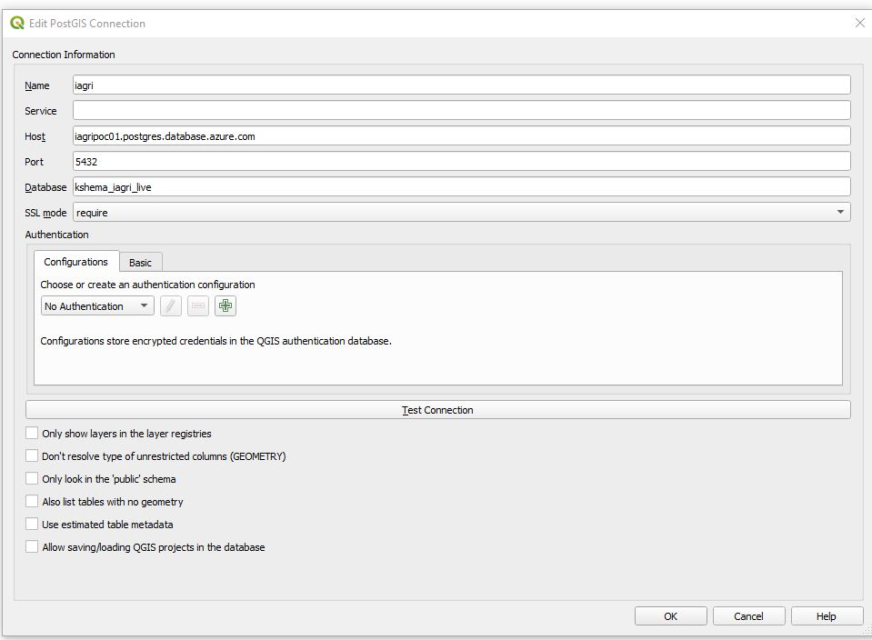

1.Click the basic here we need to enter DB user name and password.

2.Then click Test connection

3. Click ok.

Create user and password in Data Base.

Login to Pgadmin.

Right click on Login/Group Roles

Click on create

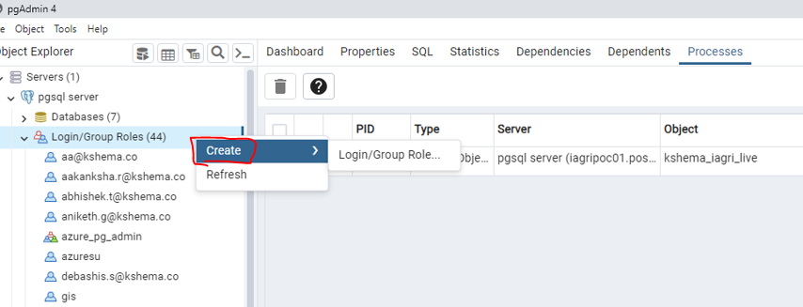

Click on General here Name: teja for login

Click on Definition here enter password and save

